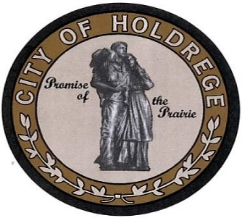

**City of Holdrege**

**Statement of Interest**

**Public Body Membership**

Thank you for your interest in serving on one of the City’s many public bodies. Please use this form to provide helpful information about yourself to help determine a good match between you and the public body you want to serve.

Your name:__________________________________________________________________

Your Home Phone Number: ______________________Cell number:____________________

Your address: _________________________________________________________________

____________________________________________________________________________

Your email address:

____________________________________________________________________________

Briefly describe which public body of the City you would like to serve and why.

_____________________________________________________________________________

_____________________________________________________________________________

_____________________________________________________________________________

_____________________________________________________________________________

Please list your current organizational affiliations and your role in each:

1. ___________________________________________________________________________

2. ____________________________________________________________________________

3. ____________________________________________________________________________

4. ____________________________________________________________________________

Which of your skills are you most eager to utilize. Check all those that apply:

|  |  |  |
| --- | --- | --- |
| * Board development * Strategic planning * Program development | * Financial management * Evaluation * Community networking | * Training * Marketing * Volunteer management |

Do you have other skill(s) that you would like to put to use?

______________________________________________________________________________

______________________________________________________________________________

What would you like to get out of your participation on the Board? (e.g., experience/skill development, municipal involvement, personal satisfaction)

_____________________________________________________________________________

_____________________________________________________________________________

_____________________________________________________________________________

_____________________________________________________________________________

If selected to serve on a board or committee, I will be able to provide 2-4 hours per meeting in preparation and attendance and declare that no conflict-of-interests exist between my membership and the responsibilities of the public body.

Signature: _____________________________________ Date:______________________

If you are not selected as a member of the board you identified, would you like to volunteer your skills and interests on a different board or committee of the City?

|  |  |  |
| --- | --- | --- |
| * Yes | * No | * Perhaps * Call me |

A list of the City’s authorities, boards and commissions and a brief description of their purpose is attached for your convenience.

*To be considered for appointment to one of our authorities, boards or commissions or to fill vacancies of elected officials, please complete this form and return it by mail or personal delivery to The City of Holdrege, Office of Mayor, PO Box 436, Holdrege, NE 68949-0436.*