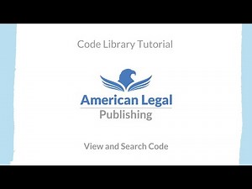 | How to View and Search Code on the American Legal Code Library  This tutorial will teach you how to view code(s) and use basic search functions on the American Legal Publishing Online Code Library. To research codes at the American Legal Code Library please visit: https://codelibrary.amlegal.com/ Since 1934, the codification experts at American Legal Publishing have provided reliable, quality, affordable ...  www.youtube.com

